**Lab Assignment No. 06**

**Title: Design and deploy a web application in a PaaS environment**

1. Search for AWS Amplify service

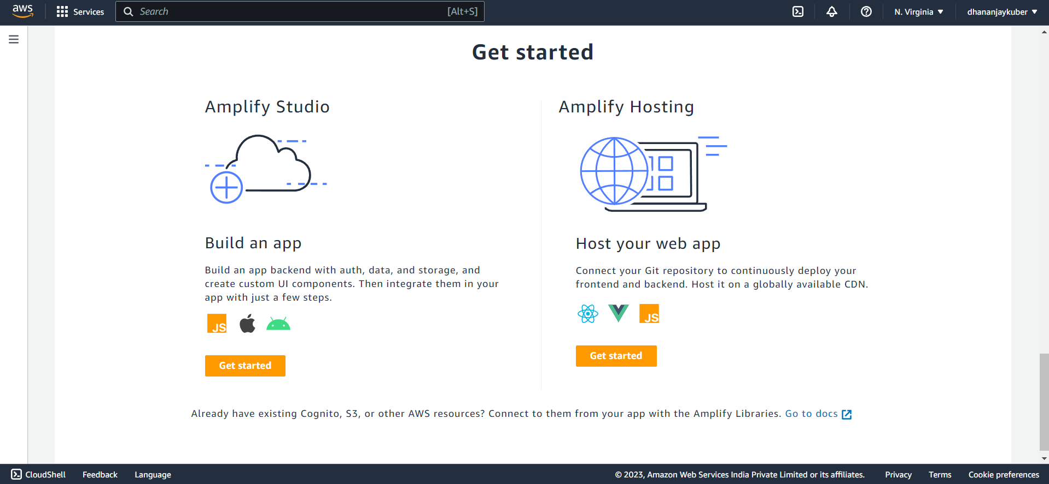

1. Click on **Get Started** to Host your Web app
2. Select Github as we already have our project on Github (react app)

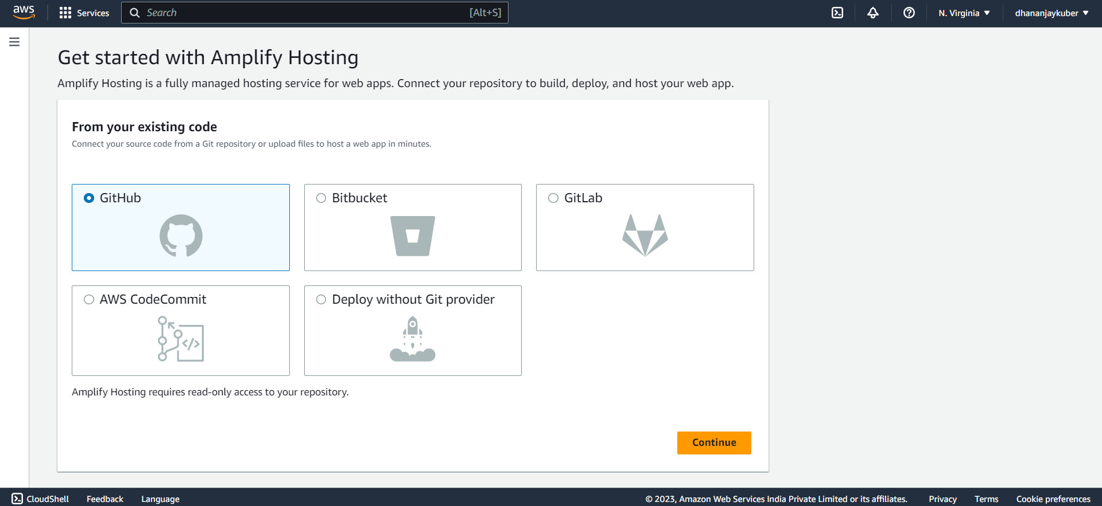

1. Select the GitHub repository and branch name

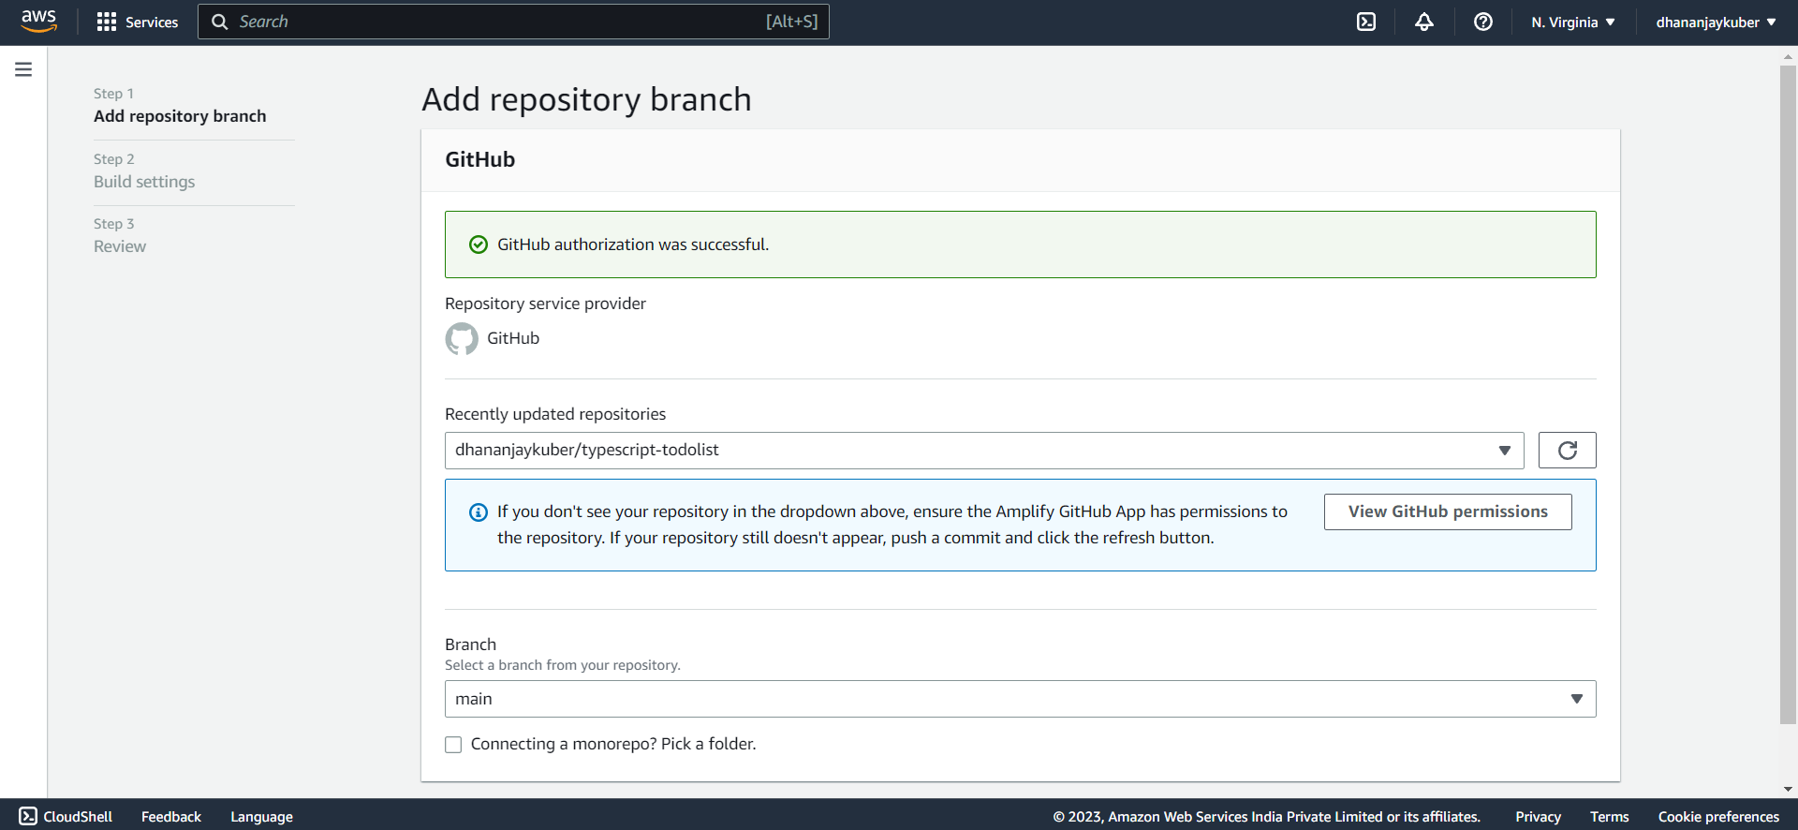

1. Click on **Next**

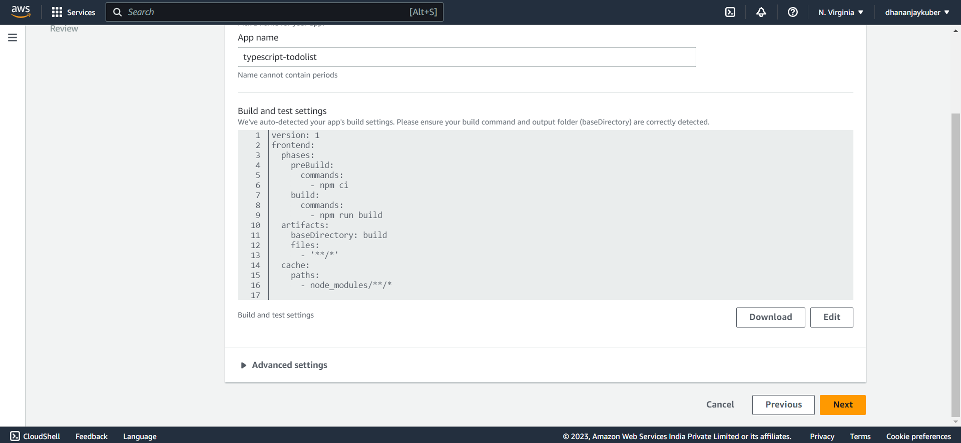

1. Click on **Save and deploy**

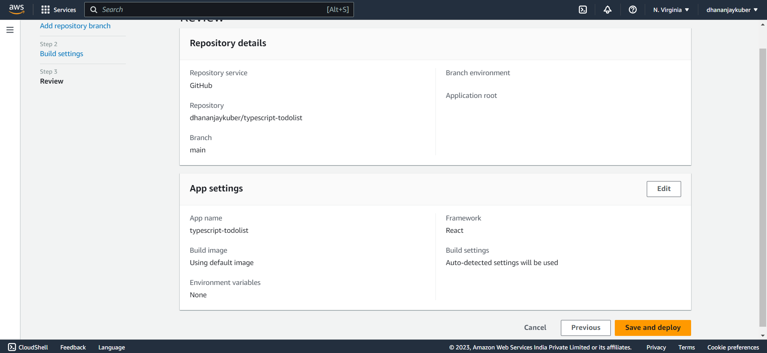

1. Now it will Provision, Build and Deploy the application

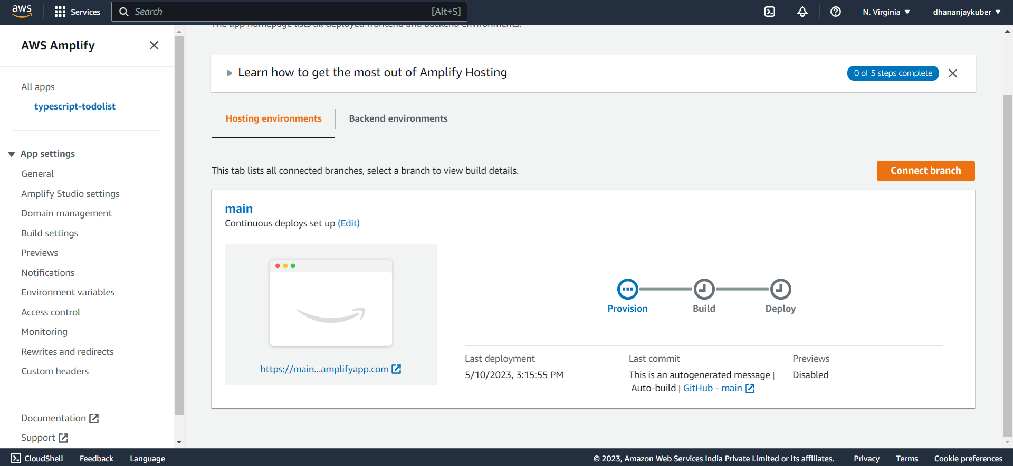

**Todo application is available at:** [**https://main.d2sh7iimvz4bez.amplifyapp.com/**](https://main.d2sh7iimvz4bez.amplifyapp.com/)

